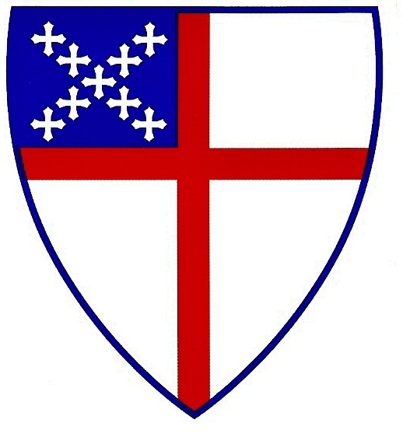
Grace Mission
Episcopal Church

Post Office Box 10472
Tallahassee, FL 32302
(850) 224-3817

September 13, 2011

“All authority in heaven and earth has been given to me.
Therefore go and make disciples of all nations, baptizing them in
the name of the Father and of the Son and of the Holy Spirit, and
teaching them to obey everything I have commanded You.”
Matthew 28:18-20

Why did the Holy Spirit ensure that there are seven statements of Christ’s Great Commission in the New Testament – one each in Matthew (28:18-20), Mark (16:15-18), and Luke (24:46-49), and two each in John (17:18; 20:21-23) and Acts (1:8; 10:42)?

Is it not because Jesus believed before he left, the importance to drill into his disciple’s minds the priority of the work of saving souls for eternity? Now of course the Great Commission would be meaningless if those who obeyed it did not also obey the Great Commandment to love God and our neighbor.

Each day at Grace Mission we try to keep the Great Commission and the Great Commandment priorities in the work that we do. We continue to challenge ourselves with the dual responsibility to live the Gospel in society and to take the Gospel to the unreached. We proactively go after the lost, love them and proclaim the Gospel. We continue to follow the agenda of Jesus, who “came to seek and to save the lost” (Luke 19:10).

The stark fact of lostness in the world places before us the urgency of evangelism. Please consider helping us go after the lost, love them and proclaim the Gospel. Grace Mission needs your help!

For His Sake,

Pastor Amanda⁺

